**Getting Started :**

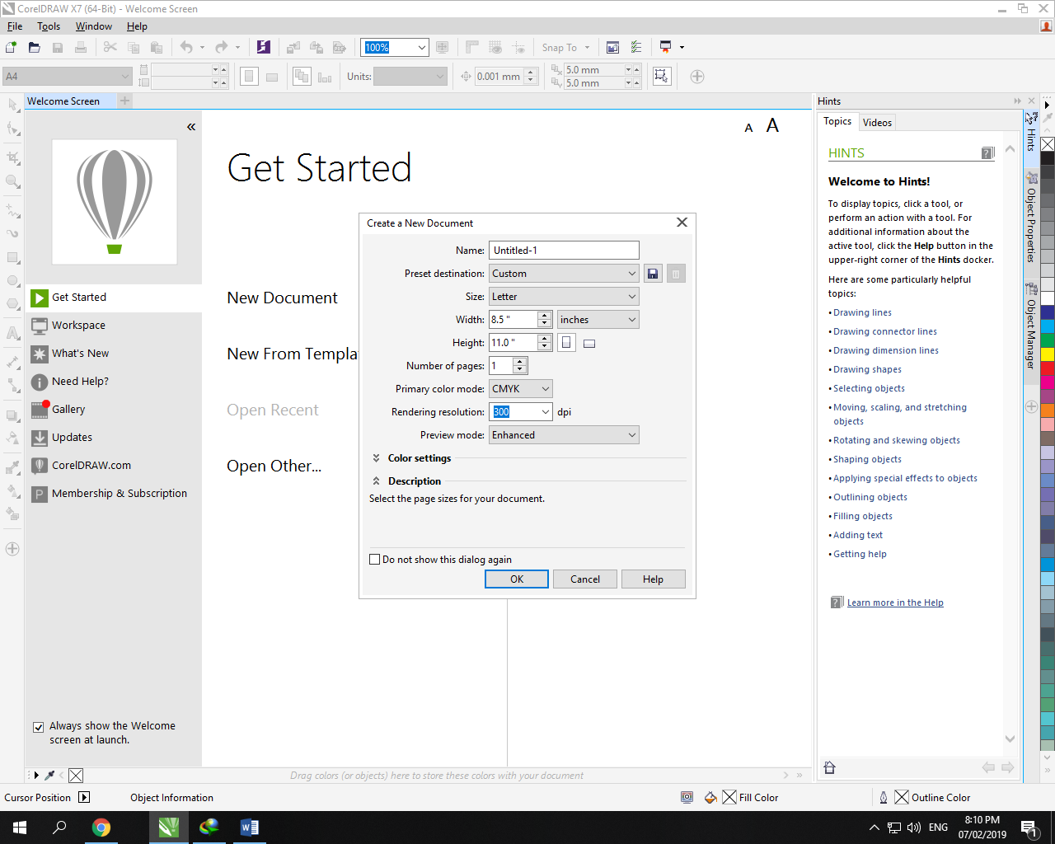

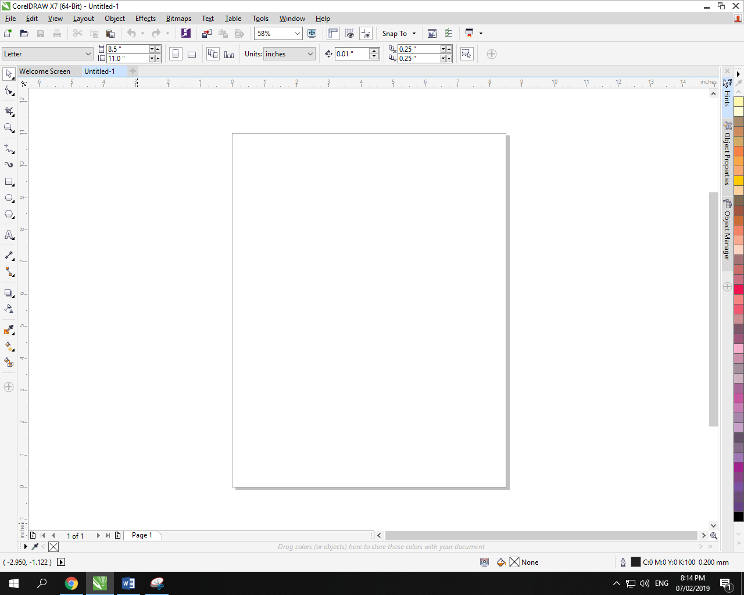

Select Tool : (Pick tool ):

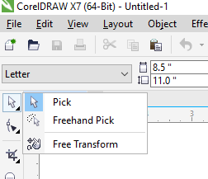

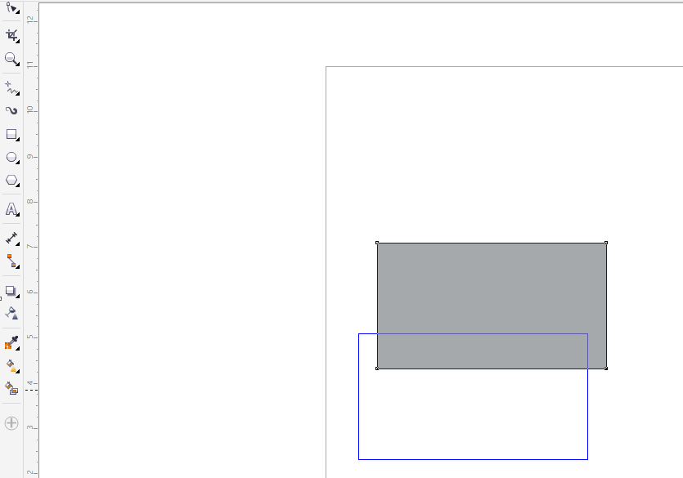

Used for moving and selecting objects.

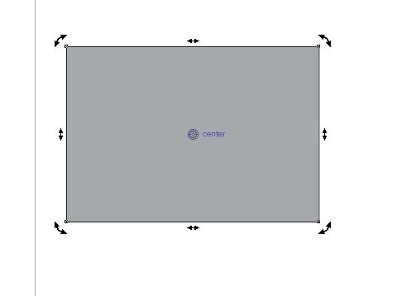

Click on center for further options.

#press shift for equal resizing

**Free hand pick tool :**

Used for selecting specific region but whole element should be in the region .



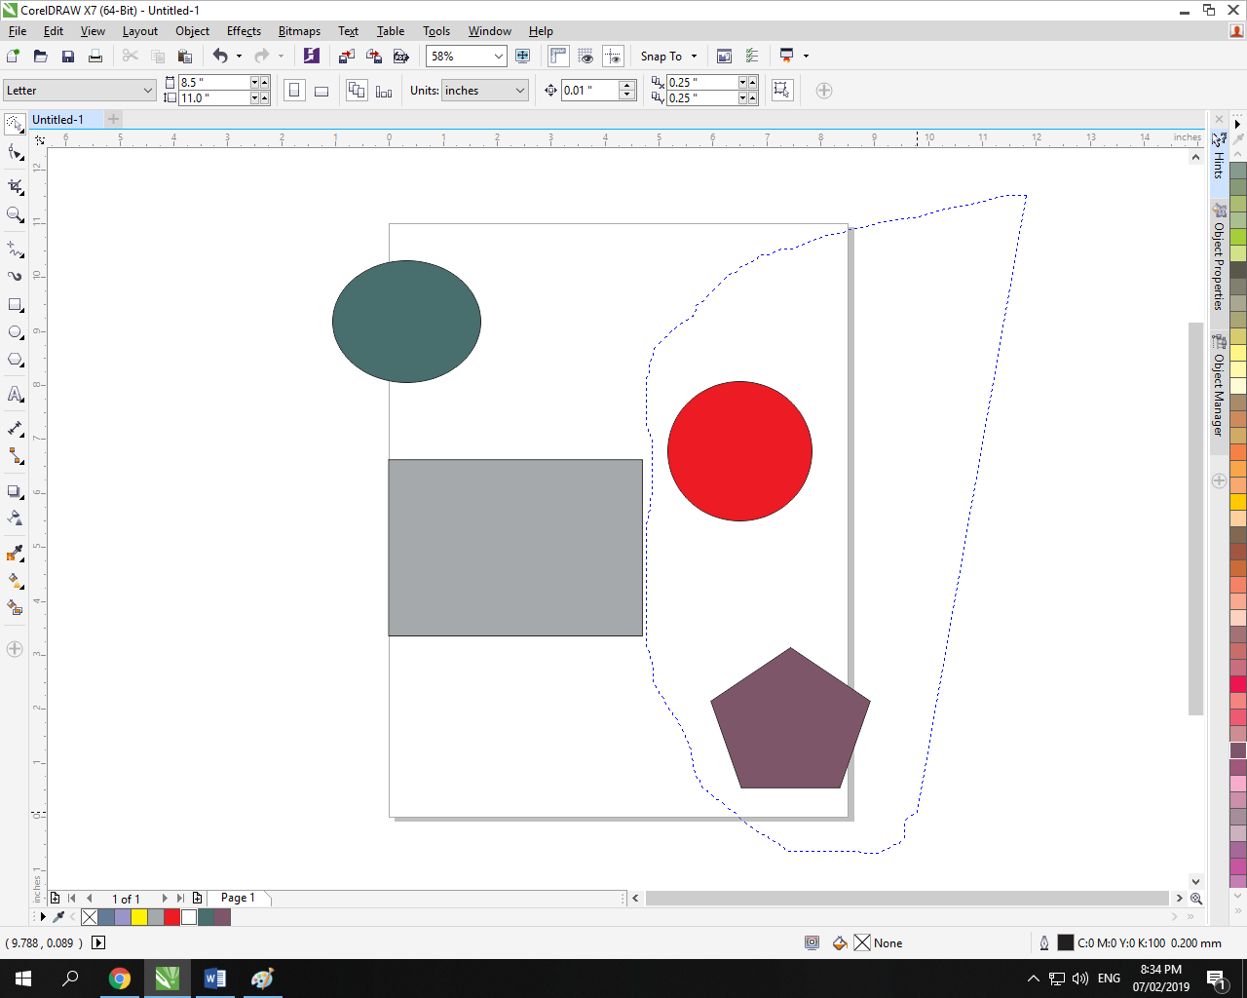

Free Transform :



Used for freely scaling objects .

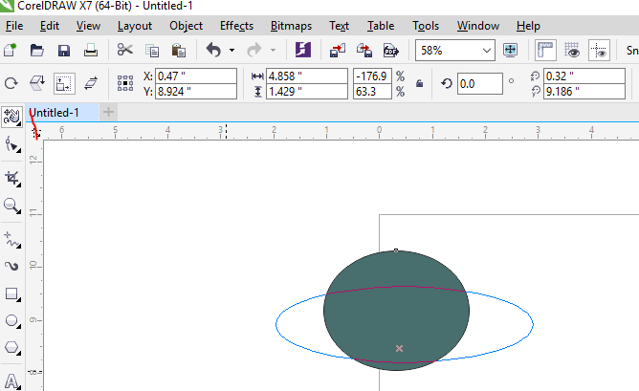

**Shape Tool :**

Used for adding curves to a shape .

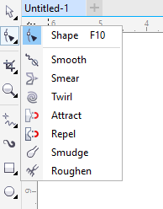

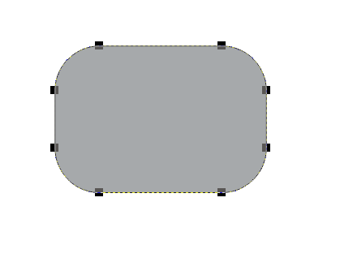

**Convert to curves :**

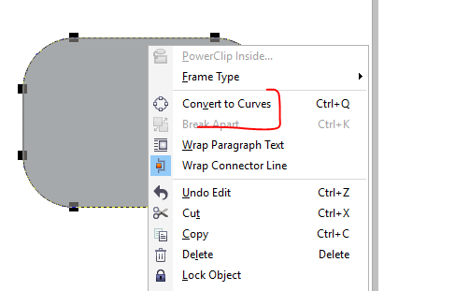

Lets u easily change any point .

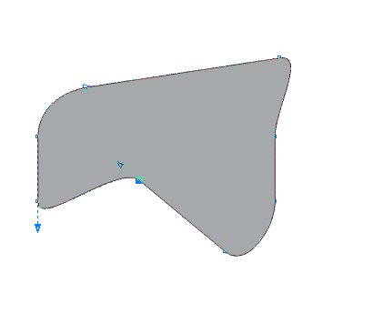

Add or delete nodes :

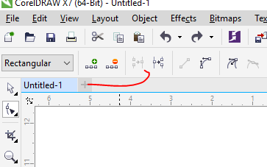

**Border :**

Right click to change border color .

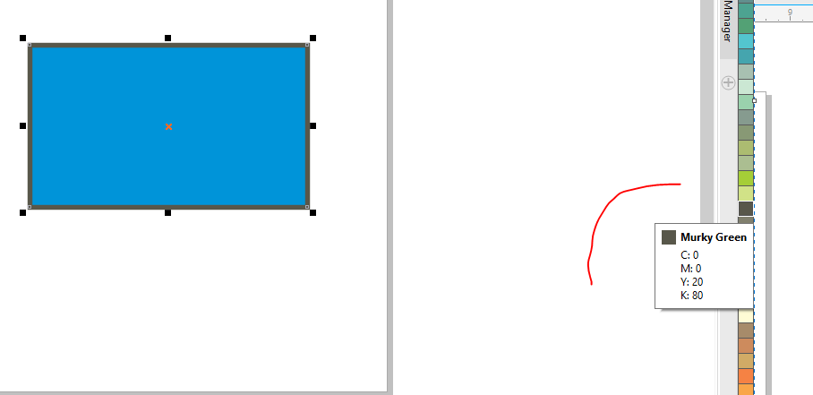

**For border radius :**

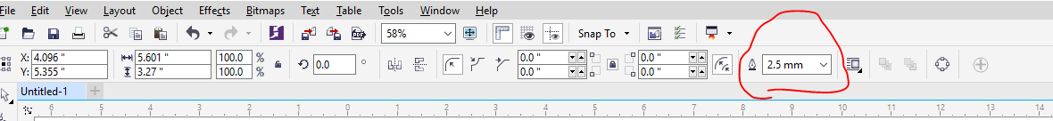

**Smooth tool :**

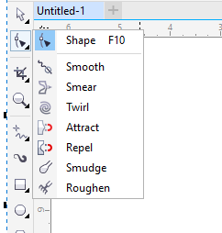

Smoothes edges ..

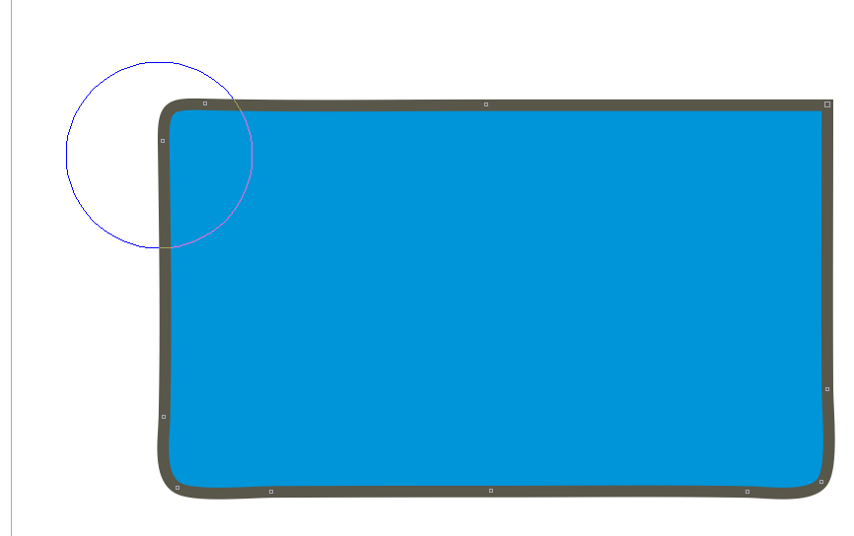

**Smear tool :**

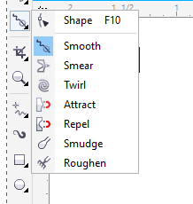

Can drag any portion of shape and change it.

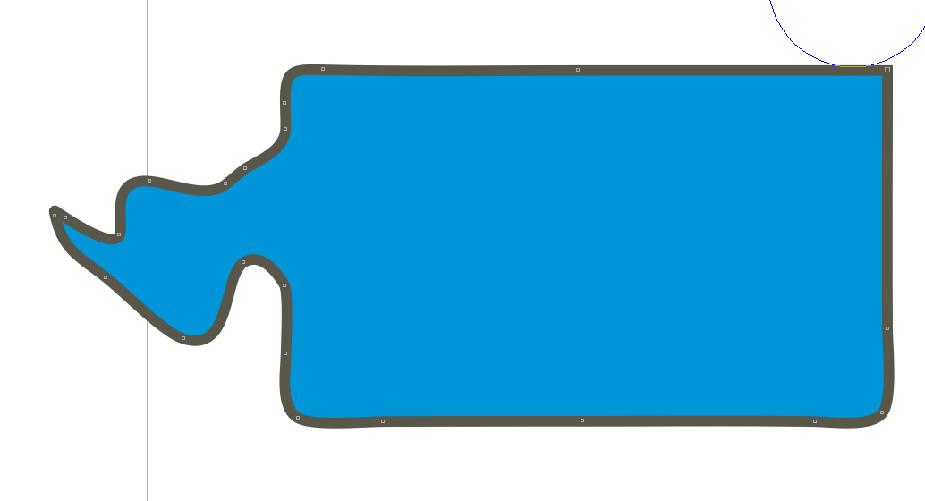

**Twirl Tool :**

Creates a swirl pattern in the area .

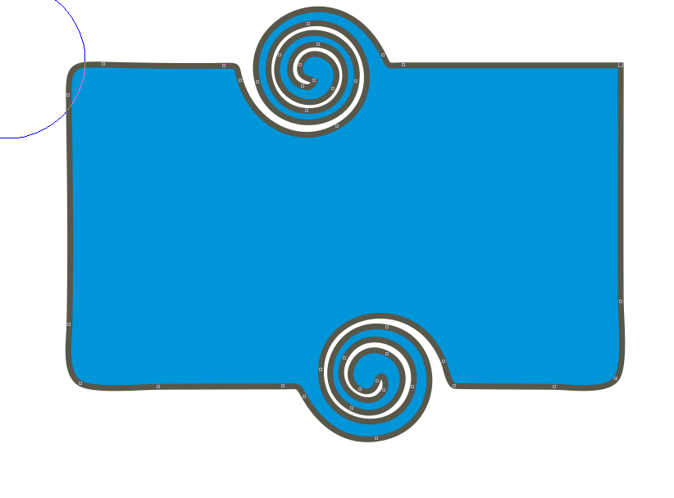

Changing position of swirl :

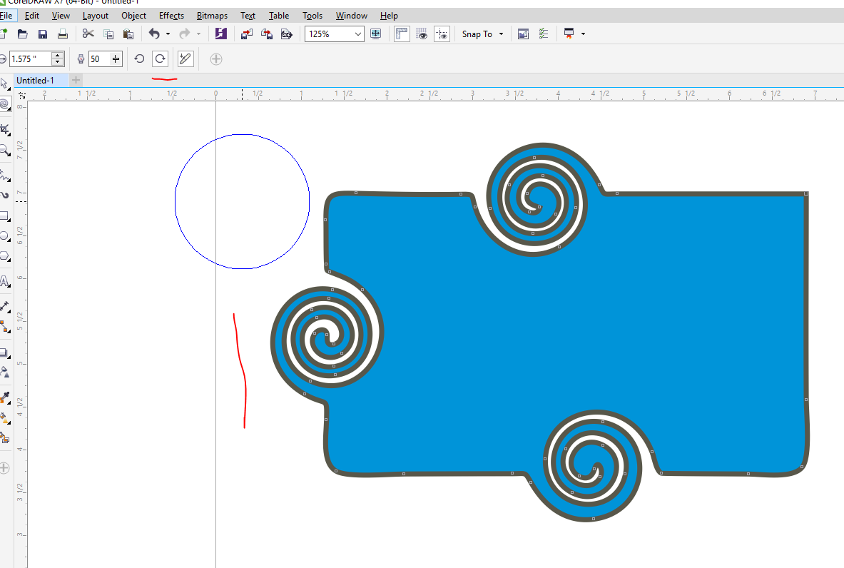

**Roughen tool :**

Makes pointy edges .

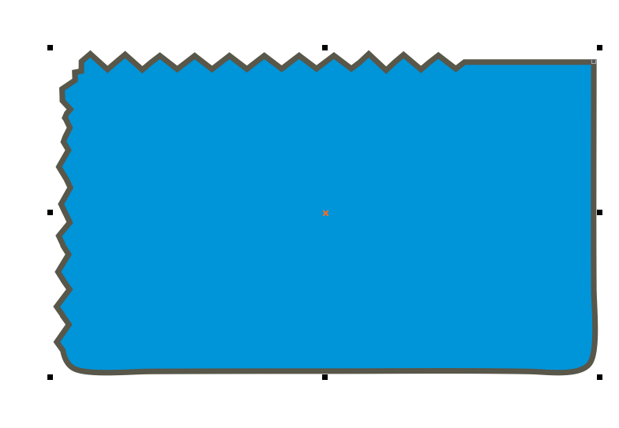

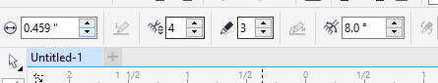

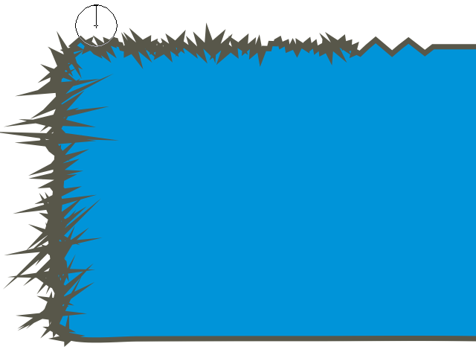

**Crop Tool :**

Cuts out the remaining are which is not in selected region .

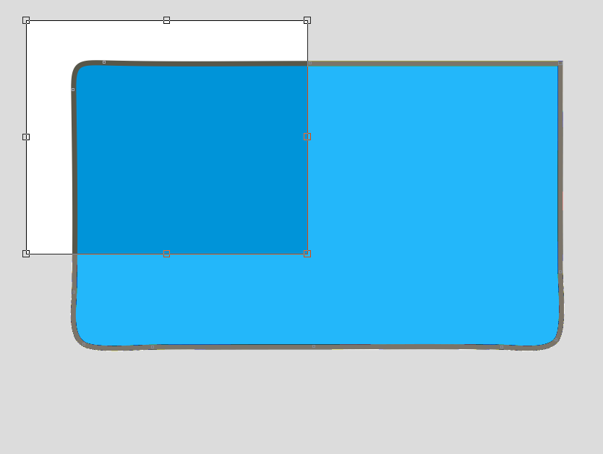

**Knife TOOL :**

Makes new shape from cut part.

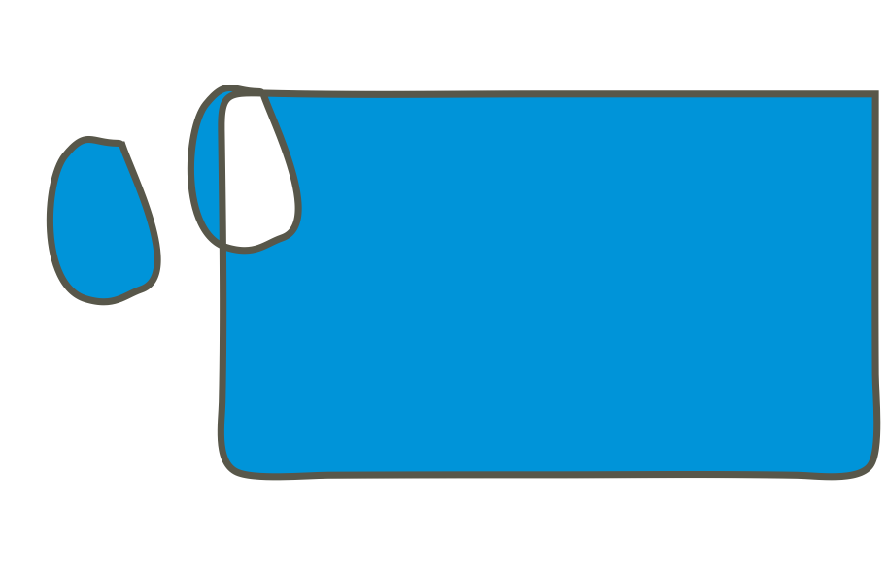

**Virtual Segment delete :**

Deletes any shape

**Eraser :**

Simple eraser .

**Free hand design tool :**

Works like a pencil .

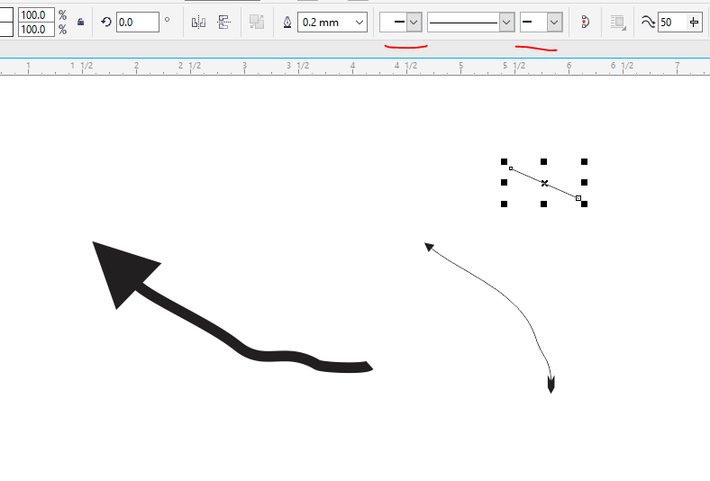

Radius … starting and ending points can be adjusted .

**Draw a Straight line :**

Click a start point , hold shift then click an end point .

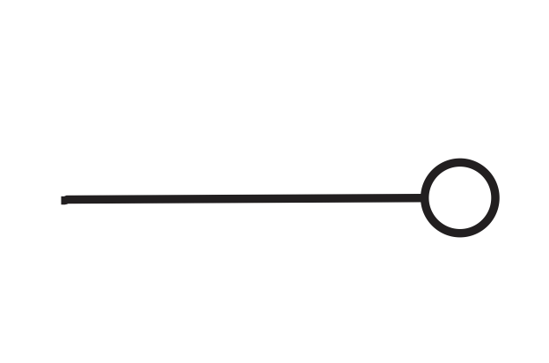

**Artistic Media tool :**

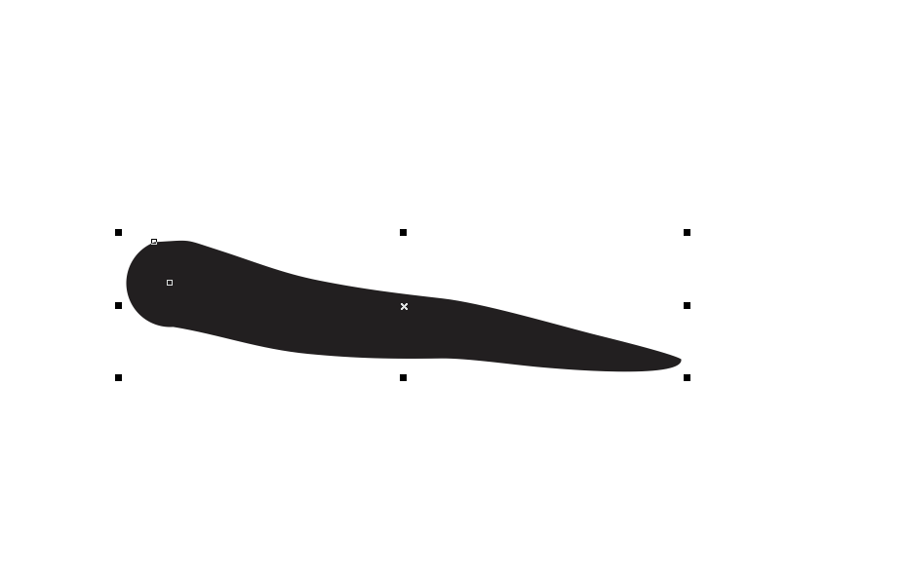

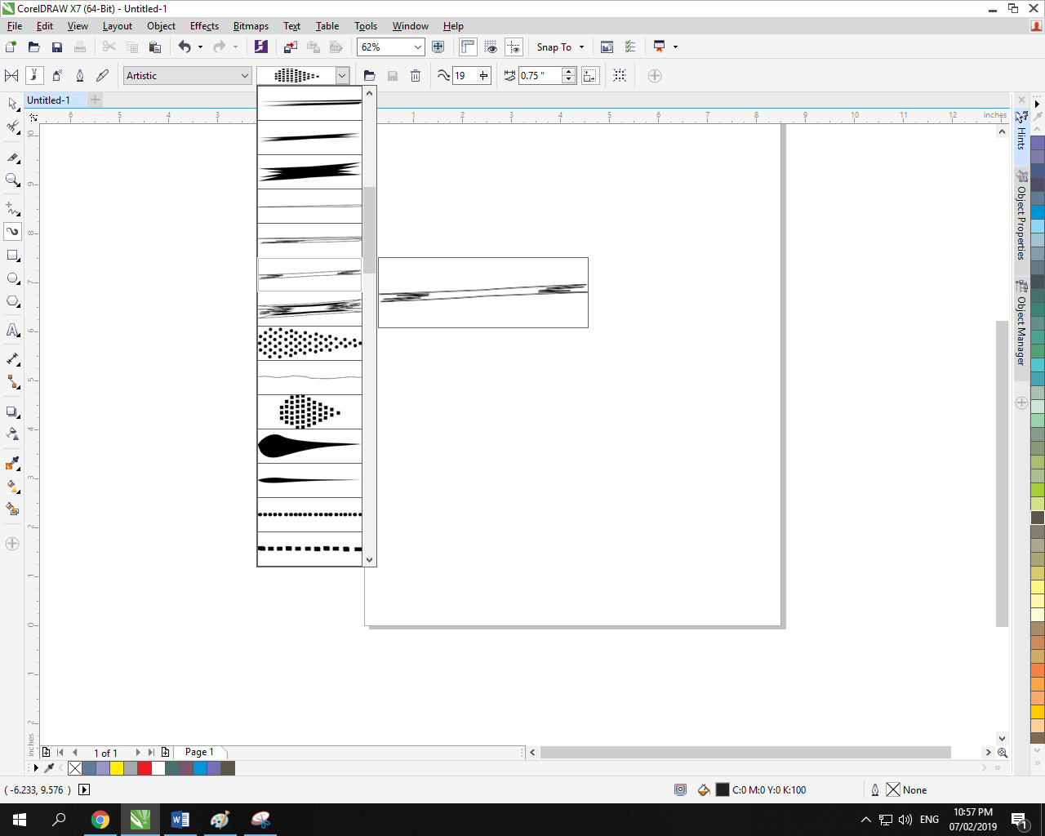

Has different brushes to make patterns .

**Rectangle tool :**

Changes edges .

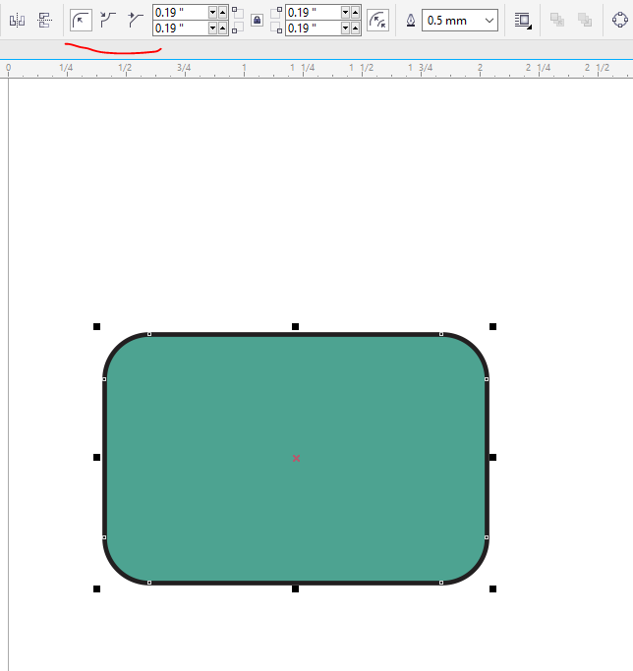

**Ellipse tool :**

Hold control for accurate scale .

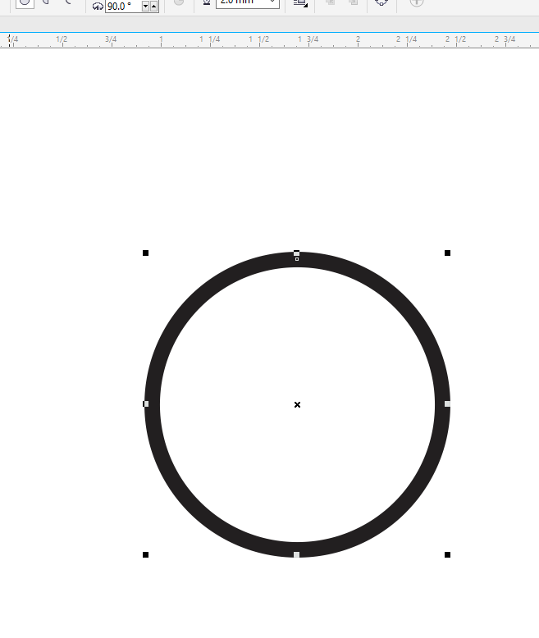

**Duplicate :**

Press ctrl + d on selected shape .

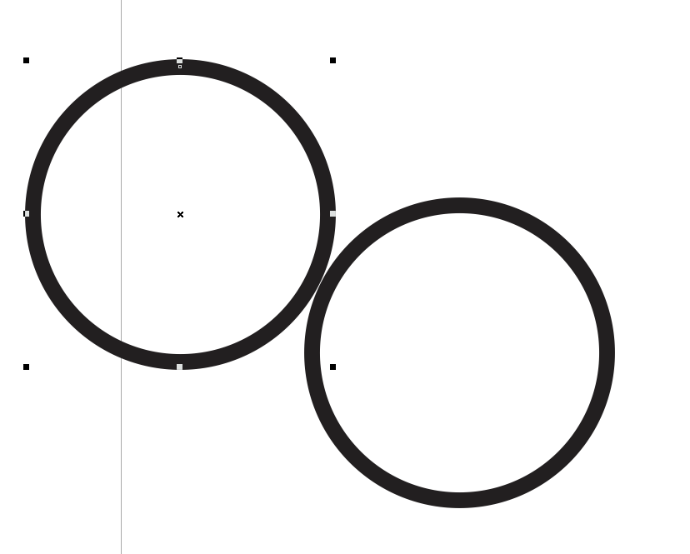

**Star and complex Star :**

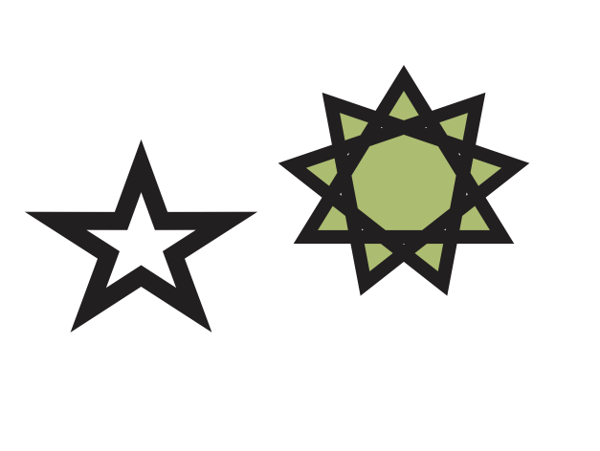

**Table :**

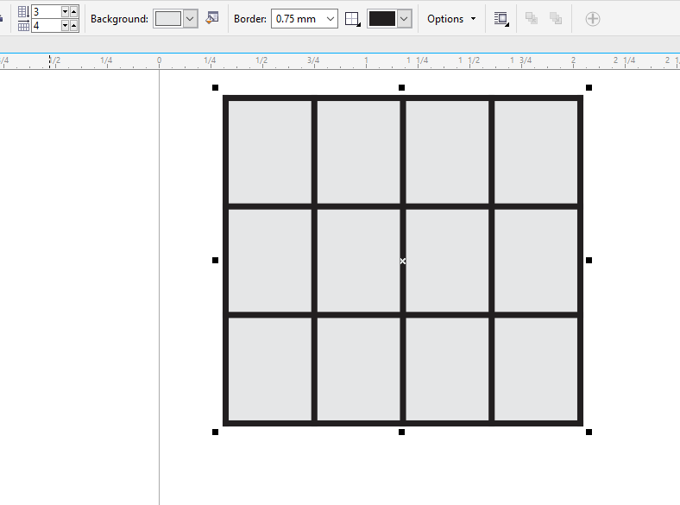

**Angular dimesnsion :**

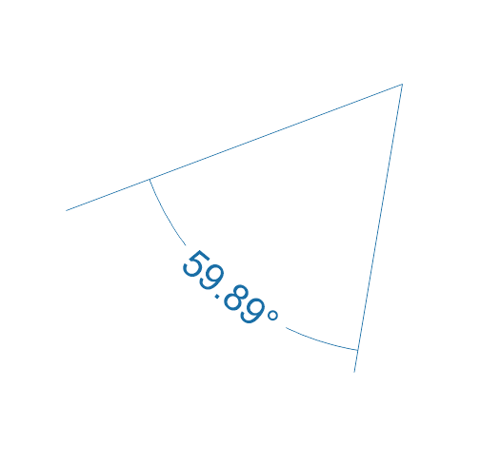

**Drop Shadow :**

Adds shades in an object .

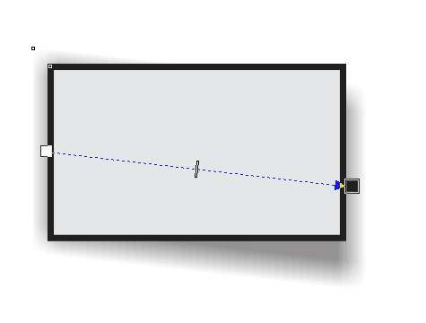

**Contour Tool :**

Used to make an object from an object.

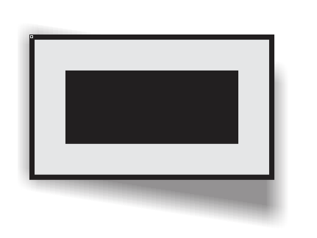

**Extrude :**

**Makes 3d objects :**

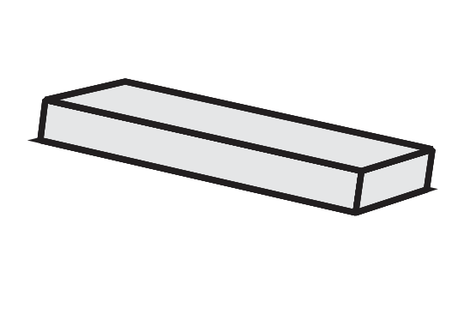

**Transparency :**

Works for certain portions .

